DRE DOUGIE
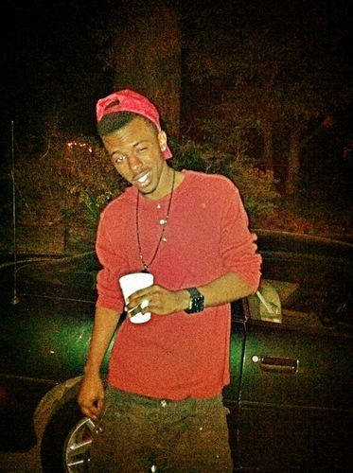
Rapper, Singer, Producer, DJ
For Booking, Features, or Beats
dredougie@gmail.com
kgurlballin@yahoo.com
(901) 345-6789

Bio
DRE DOUGIE IS A YOUNG UPCOMING STAR ON THE RISE.SO YOUNG BUT YET MUCH TALENT.DRE IS ALSO KNOWN AS A PRODUCER/SINGER/RAPPER/C.E.O. OF DRESKII PRODUCTIONZ AND CO-C.E.O.OF DANGERZONE ENT.HE STARTED AT THE AGE OF 13..BORN IN CLARKSVILLE,KENTUCKY AND RAISED IN MEMPHIS TENNESSEE,DRE ATTENDED TREZEVANT HIGH SCHOOL C/O 2010.HE GRADUATED AS A JUNIOR. HE CURRENTLY ATTENDS COLLEGE.HE IS THE BROTHER OF LOCAL RAPPER/PRODUCER N MYSPACE ARTIST BIGSOUTH THA TRUTH A.K.A. SOUTH KAL AND THEY WORK TOGETHER TO SPREAD THE SOUND OF THEIR URBAN MUSIC TO ONE AND ALL.

PREVIOUS WORK:

Mixtapes:
2 Be Loved (07/07/2011)
DJ Johnny Blaze, DreSkii Productionz, D.Z.E.
http://www.datpiff.com/Dre-Dougie-2-Be-Loved-mixtape.248864.html

Evolution of Dre (08/31/2010)
Hosted by D.Z.E. Danger Zone Ent. Dre Skii Productions
http://www.datpiff.com/Dre-Dougie-Evolution-Of-Dre-mixtape.148695.html

Singles:



